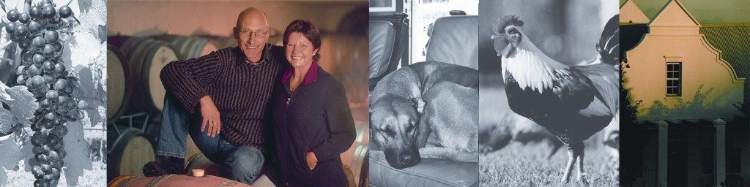

Bein merlot
w.o.stellenbosch

1 our story Being a Swiss couple with an old passion for wine and South Africa, we came a few years ago to Stellenbosch and found a miraculous piece of land in the heart of the beautiful Cape Winelands. Having worked for many years as veterinary surgeons, we decided for a career changew, went back to university and emerged four years later as winemakers. Today, we concentrate on creating an ultra-premium quality Merlot, carefully crafted from our own vineyard in naturally limited quantity. Striving for the best possible result, we personally put hands on from vineyard to bottling, producing a Merlot in a classic, elegant style.
viticulturist and winemaker: The philosophy behind the name is our own personal, hands-on commitment from planting to bottling. Both of us have a BSc degree in Oenology and Viticulture from the Stellenbosch University. Besides, we both have a doctor’s degree in veterinary science, and worked before as vets for 20 years in our native country Switzerland.

2 vineyard particulars Petrus Place on Polkadraai Road, Stellenbosch, 2.2 ha under Merlot, established 1996
The vineyard is our passion. The site is ideally suited for growing Merlot, situated on the cool southern slopes of the Polkadraai Hills in Stellenbosch and blessed with deep and highly weathered granite soils. The proximity to the coast, with its beautiful direct view to False Bay, ensures an always fresh breeze and sufficient air humidity during the warm summer months, which is so important for a slow and even ripening.

The small size our venture allows for a caring and sustainable viticulture, ideal for optimal expression of terroir. With our love for nature, production is of
course environmentally-friendly, certified by IPW SA. To optimise our vineyard management, we make use of modern techniques such as continuous soil moisture control, computerised weather monitoring and infrared remote sensing (Precision Viticulture)

3 the cellar tailor-made for our Merlot

The completion of our own winemaking facilities in 2005 allowed us ultimately to pursue our dream of perfectionist winemaking. Designed according to the latest enological standards, the cellar is specifically tailored for the production of our quality Merlot. Though there are no fancy gadgets, process flow and equipment is of modern standards. Primarily designed around the gentlest pumping system available – a lobe pump - the layout of the cellar allows alternatively for processing must and wine by gravity. Sorting table, a gentle destemming system, temperature-controlled stainless steel fermenters and the traditional basket press are natural standards. The climate-controlled barrel cellar and storage room finally allow us to mature the young wines to perfection.
And last but not least, we can welcome visitors in our own cosy tasting room, with stunning views over the Winelands, from the Stellenbosch Mountains to the coast line of False Bay.

4 the wine an elegant Merlot from a single vineyard, in classic Pomerol style

In the production of our Merlot, the primary focus lies in the vineyard, with the ultimate ambition for an optimum fruit.

In the cellar, emphasis is laid on the gentle treatment of the fruit, from handpicking to modern extraction methods. After hand-picking and primary sorting in the field, the bunches are transported to the winery in small 15-kg-crates, in order to avoid any damage to the fruit. Arriving at the cellar, the grapes are meticulously sorted a second time on a sorting table. Fermentation takes place in temperature-controlled stainless steel tanks at temperatures of 25-28ºC, with alternating pump-overs and punch-downs for a gentle but thorough fruit extraction. Total vating time is usually 10-14 days, after which the skins are gently pressed by means of a traditional basket press and the young wine racked directly into barrel. Malolactic fermentation is conducted in barrel, and it is only after completion of this second fermentation, that sulfite is used for the first time in our wine, aiming at keeping the sulphur levels at the absolute minimum. Further maturation takes place for one year in oak barrels selected from top French cooperages (usually 40% new), followed by one year of bottle maturation in our air-conditioned bottle store before release.

